Photo :

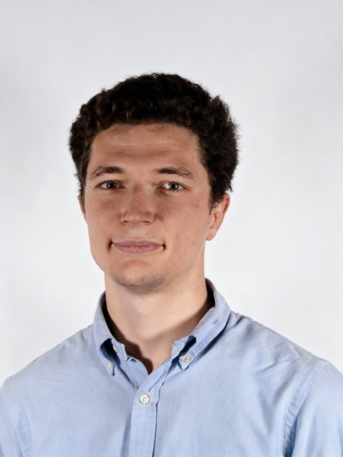

Antoine Menke

Business professional with expertise in digital advertising, media strategy, and strategic account management. Passionate about driving brand performance through data-informed marketing and high-impact partnerships.

Learn more about me

About Me:
Hello, I’m Antoine Menke, a media and advertising professional specializing in digital marketing, strategic partnerships, and performance-driven media planning.
I am currently completing an MSc in Media Management at ESCP Business School, following academic experience at ESSEC and UC Berkeley that provided a strong foundation in marketing strategy, analytics, and business management. This education complements a diverse professional background across France and the United States.
My career to date includes responsibilities in advertising sales, programmatic campaign management, and strategic account development for leading media groups and agencies. I have supported major advertisers and media agencies, managed multi-channel budgets, and contributed to revenue growth through data-informed recommendations and structured commercial execution.
With competencies spanning sales, digital media strategy, and operational rigor, I am committed to delivering measurable results and supporting organizations in achieving their marketing and communication objectives.

Education:
Msc Media Management
ESCP Business School, 2025-2026
Bachelor Business Administration
ESSEC Business School, 2019-2023
Master in Innovation and Management
UC Berkeley, 2022-2022
Skills:
• Google Ads (Search, Display, Video)
• Programmatic Buying (DV360 / The Trade Desk/ Amazon DSP)
• Google Analytics
• CRM & Sales Tools (HubSpot, Salesforce)
• Data Visualization (Looker Studio / Tableau)
• Campaign Performance Reporting & Optimization

Je te partage le CV dans mon email

Experience & Education:
MSc – Media Management
ESCP Business School • Paris, France
Sep 2025 – Dec 2026
Focused on media strategy, digital marketing, and partnership development.
Developing advanced competencies in advertising ecosystem management and strategic communication.
Account Manager
Publicis Groupe – Umandots • Paris, France
Feb 2025 – Sep 2025
Managed multi-channel programmatic campaigns for major advertisers.
Designed strategic media recommendations across video, display, audio, social, and DOOH.
Collaborated with trading and tech teams to ensure campaign performance and client satisfaction.
Advertising Sales Manager
France Télévisions Publicité • Boulogne-Billancourt, France
Jan 2024 – Sep 2024
Led digital advertising sales for major media agencies.
Supported monetization of the group’s digital inventory and external partners (Brut, Météo France, Radio France).
Drove revenue growth through strategic account development.
Digital Commercial Assistant
M6 Publicité • Neuilly-sur-Seine, France
Jul 2023 – Dec 2023
Supported sales teams managing advertising space for major advertisers and Publicis agencies.
Prepared strategic materials for management meetings and reinforced sales operations.
Field Marketing Intern
Petit Pot • Emeryville, California, USA
Jan 2023 – Jun 2023
Strengthened U.S. brand presence through in-store marketing initiatives (Costco, national retail).
Expanded distribution footprint through negotiations with regional partners.
BBA – Global bachelor’s in business administration
ESSEC Business School • Cergy, France
Sep 2019 – Jun 2023
Generalist curriculum with marketing, management, and analytics coursework.
Leadership experience in student organizations (HeForShe ESSEC – Head of Partnerships).
MBA Exchange – Business Administration
UC Berkeley • California, USA
Jan 2022 – Dec 2022
Focused on business negotiation, product strategy, and sales management.
Developed strategic and intercultural competencies through U.S. academic and professional immersion.

Certifications:

Google Ads Search Certification
Online - 2025
https://skillshop.credential.net/7e117691-aa9d-4817-8fa4-7af9b4b74452#acc.tjCuzcTi

Google Analytics Certification
Online - 2025
https://skillshop.credential.net/266ba4d2-c049-444b-958c-559a54fd72f3#acc.TWoPBvDk

Google Digital Marketing & E-Commerce Certificate
Online - 2025
https://www.credly.com/badges/02b8a8b9-bc67-431c-a9f1-6d39d7826d3f/linked_in_profile

Amazon DSP Certification
Online - 2025
https://advertising.amazon.com/academy/student/path/1532/amazon-dsp-certification

Reference :

Sebastien Noel Managing Director - Uma:ndots
Vannessa Lobbe Head of Digital Trading – France Television Publicite

